DIGITAL CHILD SAFETY HANDBOOK

We are pleased to advise that a new edition of this valuable safety resource is now valuable online with updated safety content.

We urge all parents and carers to download this latest edition and discuss the safety content with your children.

Child Safety Handbook App available for download:

Visit the Child Safety Hub

Read the Child Safety Handbook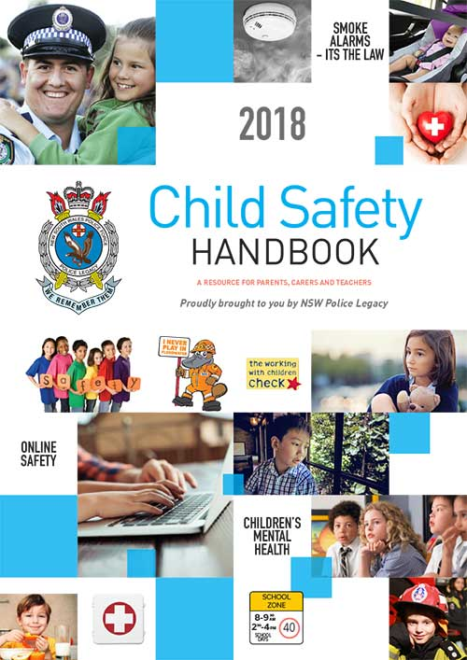
NEW EDITION AVAILABLE NOW

